Database Development using MySQL

LAB # 04



Spring 2024
CSE-403L Database Management Systems Lab

Submitted by: Ali Asghar
Registration No.: 21PWCSE2059
Class Section: C

“On my honor, as student of University of Engineering and Technology, I have neither given nor received unauthorized assistance on this academic work.”

Submitted to:
Engr. Sumayyea Salahuddin

Date:
23rd April 2024

Department of Computer Systems Engineering
University of Engineering and Technology, Peshawar
Objectives:
This lab aims at the understanding of:
- An Example SQL Database Management System i.e. MySQL
- Using MySQL Command Line in Windows
- MySQL Command Categories
- Use of MySQL Commands for a Real-World Problem

Task 4.1:
Q1: What is DDL, DML, TCL, and DCL? Explain in your own words. Also, list few commands in each language.
Ans: DDL (Data Definition Language):
DDL deals with defining and modifying the structure of database objects (like tables, indexes, views, etc.). It doesn’t manipulate data itself.
Common DDL commands: CREATE, DROP, ALTER, TRUNCATE, COMMENT, RENAME etc

DML (Data Manipulation Language):
DML is all about manipulating data within schema objects.
Key DML command: SELECT

DCL (Data Control Language):
DCL focuses on controlling access to data.
Common DCL commands: GRANT, REVOKE

TCL (Transaction Control Language):
TCL manages transactions (groups of SQL statements that are executed together).
Key TCL commands: COMMIT, ROLLBACK, SAVEPOINT

Q3: Evaluate yourself and write a note about your understanding of this lab.
Ans: I learned all the terminologies related to SQL Database Management System. I learned how to create a database when relational schema is given. I also learned how to populate and manipulate a database using DBMS.

Task 4.2:
What is the difference between SQL and MySQL? Why is MySQL used? What are its features?
Ans:
SQL:
SQL is short for Structured Query Language. SQL is the standard language to maintain and manage a database. Thus, besides a few minor syntax changes, most of the databases’ queries for retrieving, adding, or manipulating data are based on the standard SQL syntax.
MySQL:
MySQL is a relational database management system developed and released back in 1995. It was developed and sponsored by MySQL AB, which was then acquired by Sun Microsystems, which you know today as Oracle Corporation. MySQL is a combination of ‘My’ (co-founder’s daughter) and ‘SQL.’

Why use MySQL: MySQL’s versatility, maturity, open-source nature, and extensibility contribute to its widespread adoption in the database world. Whether you’re building a small web application or managing a large-scale system, MySQL remains a reliable choice!

MySQL Features:
1)Easy to Use 2) Scalability 3) Performance 4) Reliability 5) Compatibility 6) Open Source

Task 4.3:
What is database engine? What purpose does it serve? How many types of engines are supported by MySQL? Which database engine is most commonly used and why?
Ans:
Database Engine:
A database engine is the underlying system that a database uses to function. Many different technologies rely on internal "engines," which are the fundamental building blocks on which they operate.
Purpose of Database Engines:
  - Data Storage: Database engines store data efficiently on disk or in memory.
  - Data Retrieval: They retrieve data based on queries (SELECT statements).
  - Transaction Management: They handle transactions (groups of SQL statements executed together).
  - Concurrency Control: Ensures data consistency when multiple users access the database simultaneously.
  - Indexing: Optimizes data retrieval by creating indexes on columns.
Types of Database Engines Supported by MySQL:
  - MySQL supports several storage engines, each with specific features and use cases:
    - InnoDB: The default and most general-purpose engine. Supports transactions, row-level locking, and foreign keys. Recommended for most tables.
    - MyISAM: A non-transactional engine known for its speed. Suitable for read-heavy workloads but lacks features like transactions and foreign keys.
    - MEMORY (HEAP): Stores data in memory for fast access. Useful for temporary tables or caching.
    - ARCHIVE: Optimized for storing large amounts of historical data with minimal space usage.
    - BLACKHOLE: Acts like /dev/null—anything written to it disappears.
    - MERGE: Combines multiple identical MyISAM tables into a single virtual table.
    - FEDERATED: Allows data from remote servers to be accessed as if it were local.
    - EXAMPLE: A dummy engine for testing and documentation purposes.
Most Commonly Used Engine:
  - InnoDB is the go-to choice for most applications due to its reliability, ACID compliance, and support for transactions.
  - It provides row-level locking, crash recovery, and foreign key constraints.
  - InnoDB is well-suited for web applications, e-commerce platforms, and any scenario where data integrity and reliability are critical.

Task 4.4:
Specify at least fifteen (15) or more different data types supported by MySQL. Provide the description with at least one example.
Ans:
Integer (INT): Represents whole numbers (positive or negative).
Example: age INT for storing a person’s age.
Decimal (DECIMAL): Stores fixed-point numbers with specified precision and scale.
Example: price DECIMAL(10, 2) for storing a product price with two decimal places.
Date (DATE): Stores dates in the format ‘YYYY-MM-DD’.
Example: birth_date DATE for storing a person’s birthdate.
Time (TIME): Represents time values in the format ‘HH:MM:SS’.
Example: start_time TIME for recording event start times.
Datetime (DATETIME): Combines date and time in the format ‘YYYY-MM-DD HH:MM:SS’.
Example: created_at DATETIME for timestamping record creation.
Timestamp (TIMESTAMP): Similar to DATETIME but automatically updates on data modifications.
Example: last_modified TIMESTAMP for tracking changes.
Char (CHAR): Fixed-length string with a specified maximum length.
Example: country_code CHAR(2) for storing country codes.
Varchar (VARCHAR): Variable-length string with a maximum length.
Example: product_name VARCHAR(255) for product names.
Text (TEXT): Stores large text data (longer than VARCHAR).
Example: description TEXT for product descriptions.
Boolean (BOOL or BOOLEAN): Represents true or false values.
Example: is_active BOOLEAN for tracking active status.
Enum (ENUM): Defines a set of allowed values.
Example: gender ENUM('Male', 'Female', 'Other') for gender selection.
- Set (SET):
  - Similar to ENUM but allows multiple values.
  - Example: interests SET('Reading', 'Traveling', 'Cooking') for hobbies.
- Binary (BINARY):
  - Stores binary data (e.g., images, files).
  - Example: profile_picture BINARY for user avatars.
- Blob (BLOB):
  - Large binary object for storing unstructured data.
  - Example: resume BLOB for job applicants’ resumes.
- JSON (JSON):
  - Stores JSON-formatted data.
  - Example: user_data JSON for flexible user attributes.
Remember that choosing the right data type depends on your specific use case and data requirements! 😊📊🔍¹²³⁴.

Enum (ENUM): Defines a set of allowed values.
Example: gender ENUM('Male', 'Female', 'Other') for gender selection.
Set (SET): Similar to ENUM but allows multiple values.
Example: interests SET('Reading', 'Traveling', 'Cooking') for hobbies.
Binary (BINARY): Stores binary data (e.g., images, files).
Example: profile_picture BINARY for user avatars.
Blob (BLOB): Large binary object for storing unstructured data.
Example: resume BLOB for job applicants’ resumes.
JSON (JSON): Stores JSON-formatted data.
Example: user_data JSON for flexible user attributes.

Task 4.5:
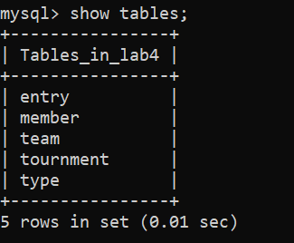

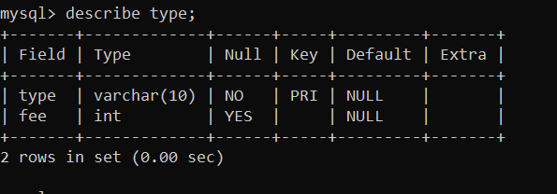
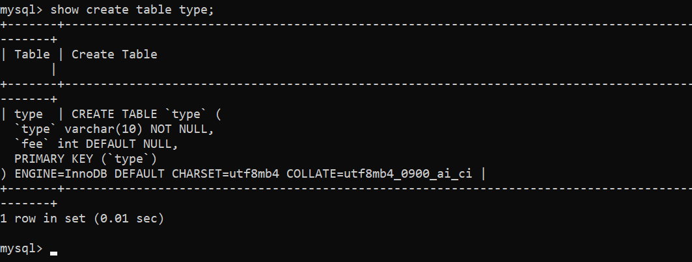

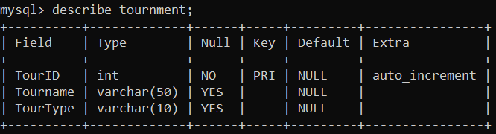
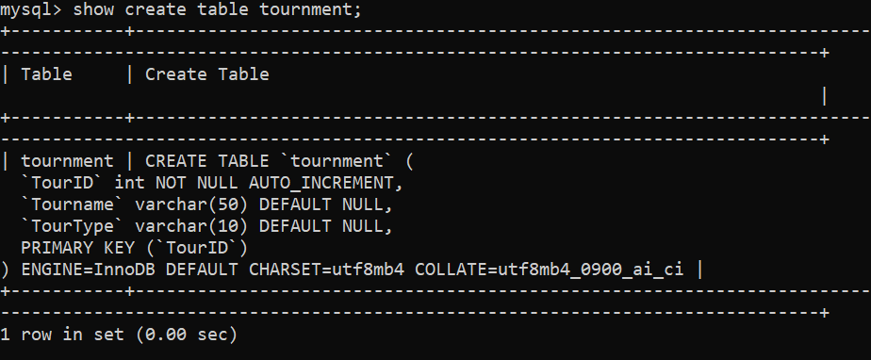
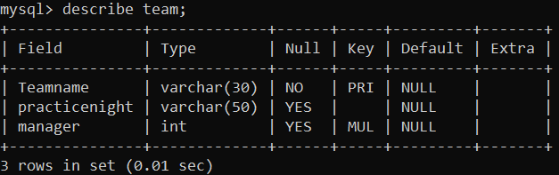

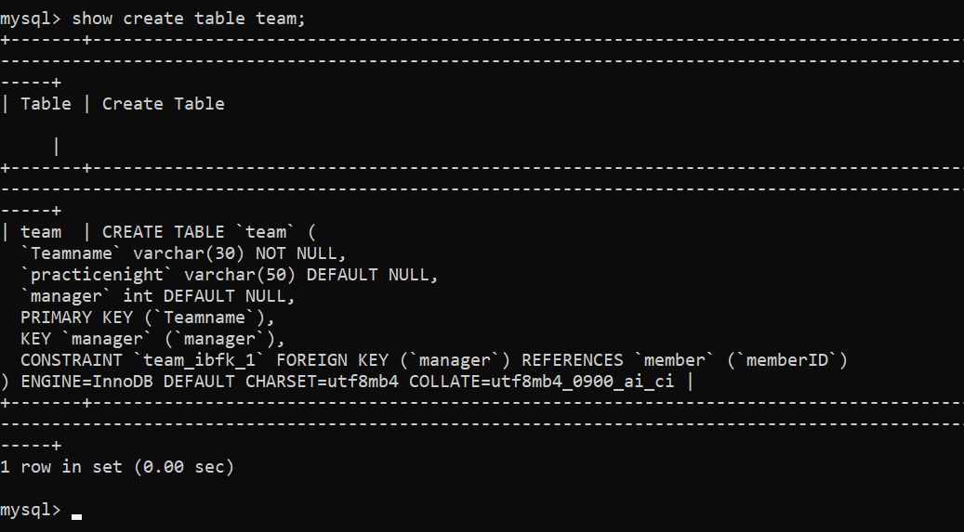
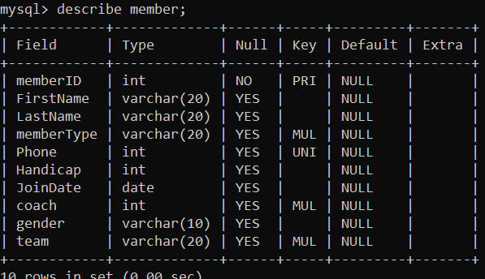

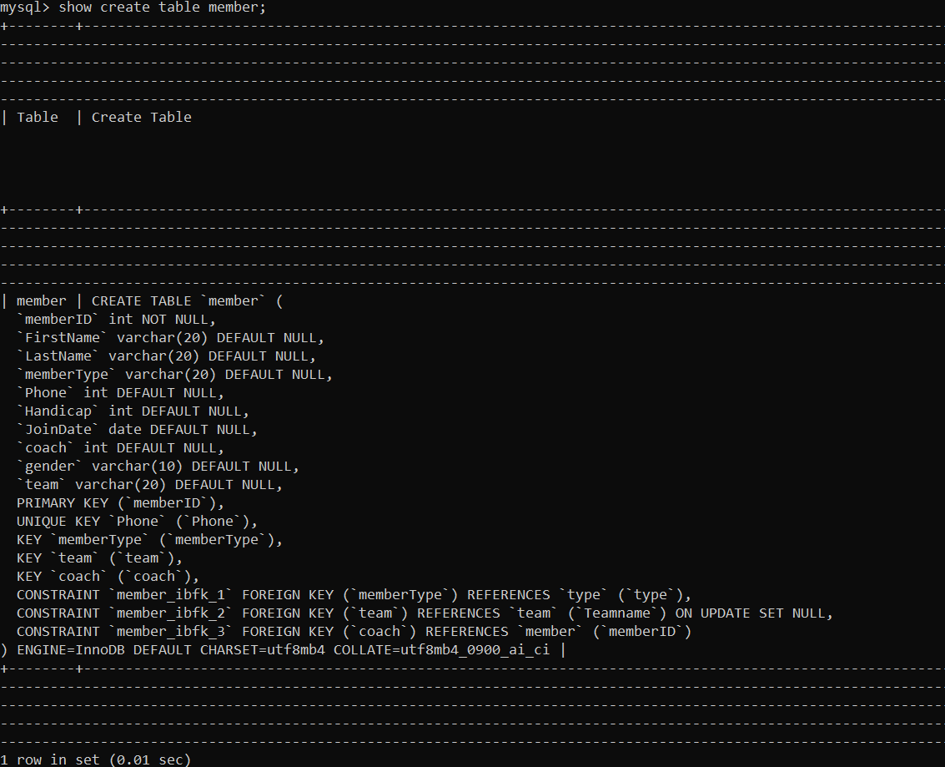

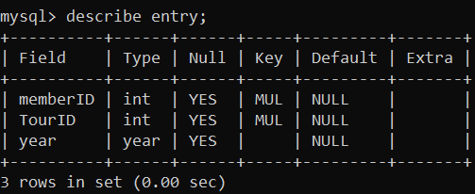
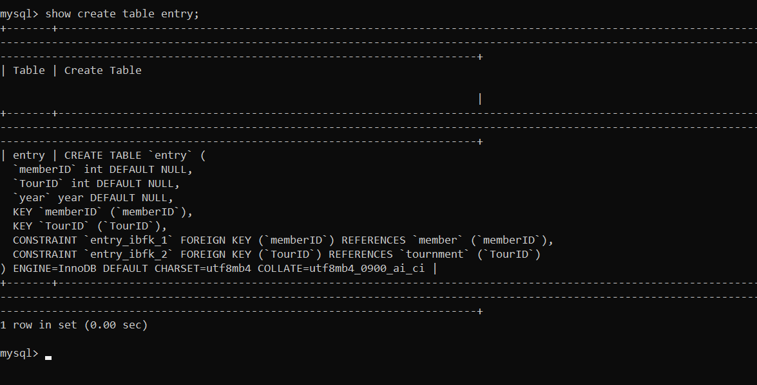

Task 4.6:
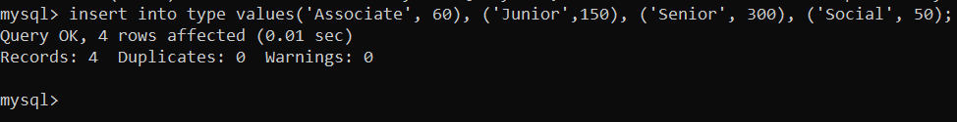
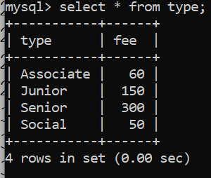

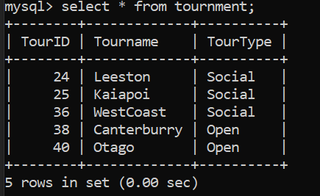

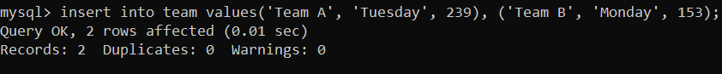
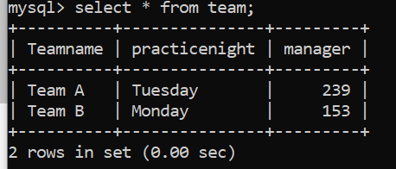

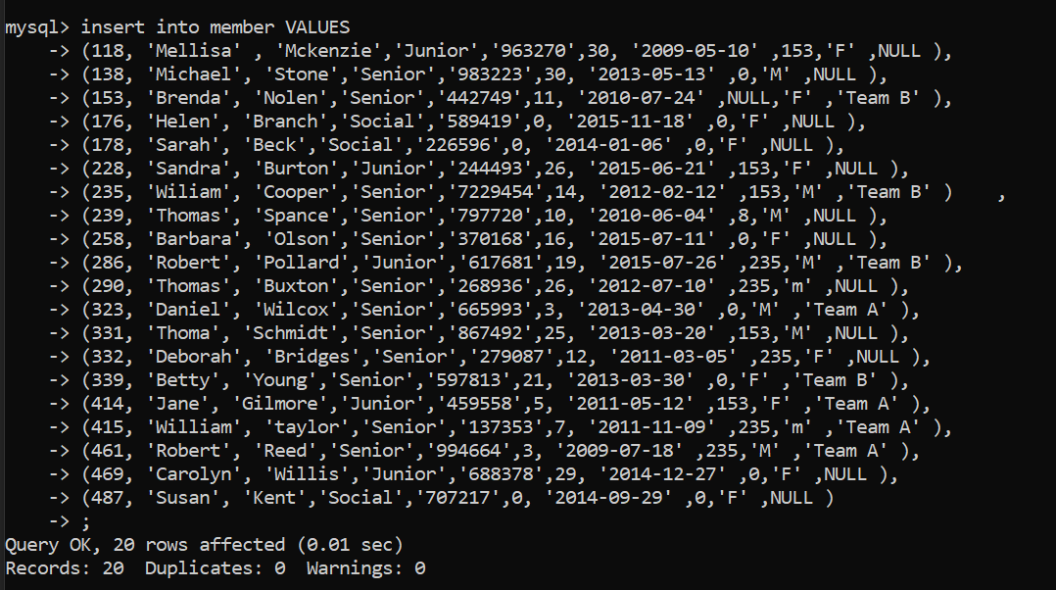
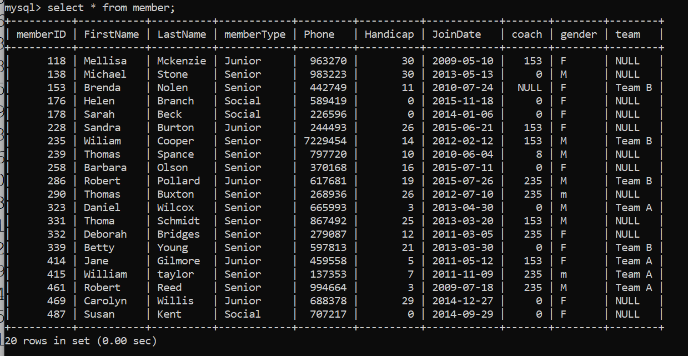

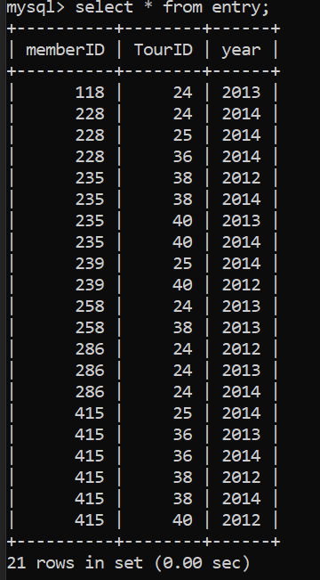
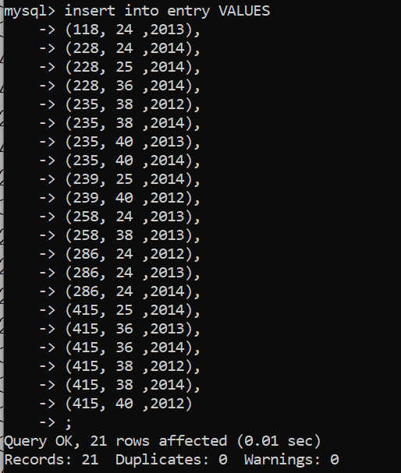

Task 4.7:
Write the query for the following:
a) List the first name, last name, and phone numbers of all the members.
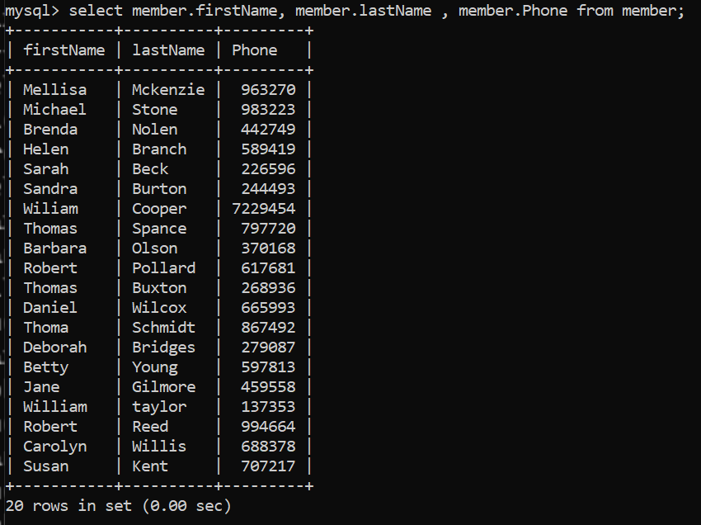

b) List complete information of all the male members.
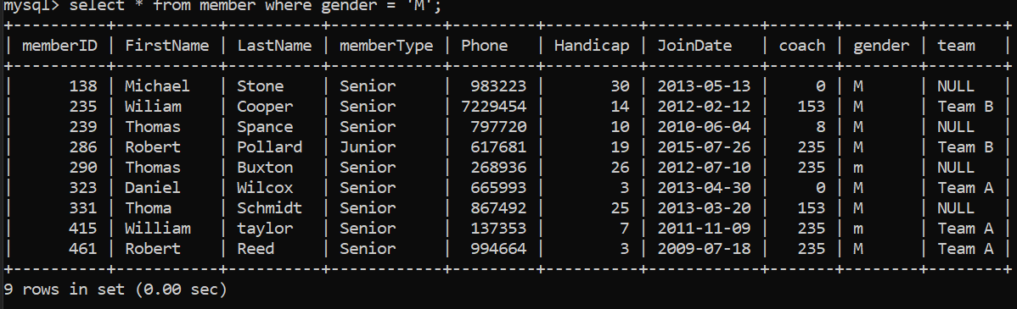

c) List complete information of all the members who joined after 01-01-2013.
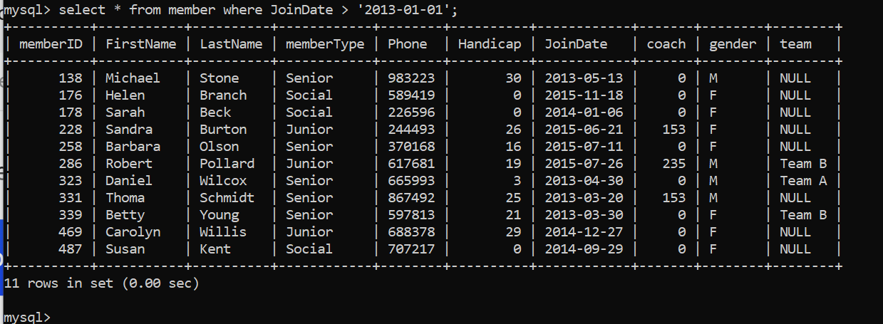

d) List name of all the members who belonged to Team A.
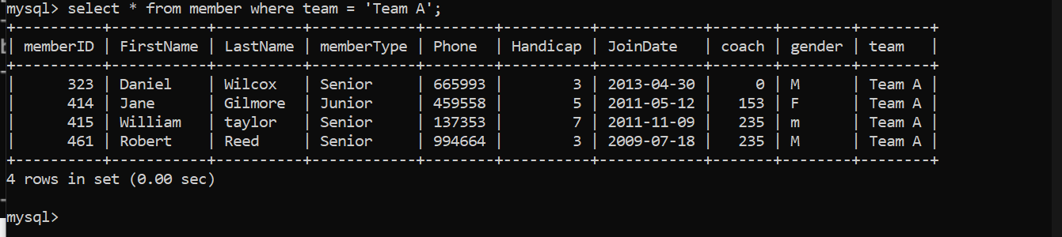

e) List complete information of all the senior members.
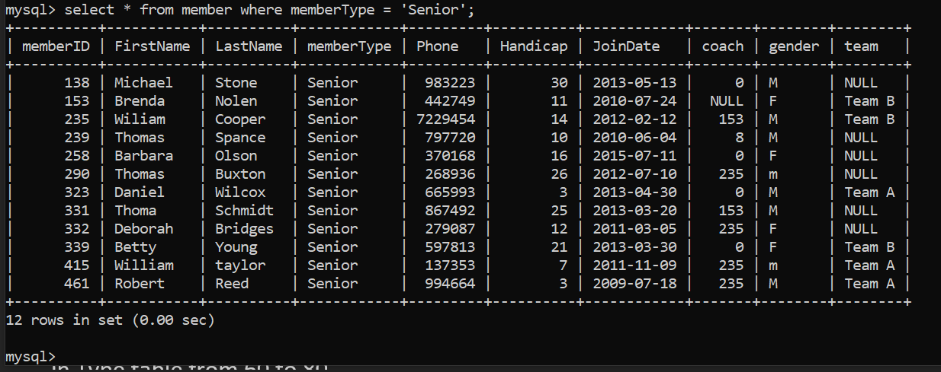

f) List complete information of all the members in order of LastName.
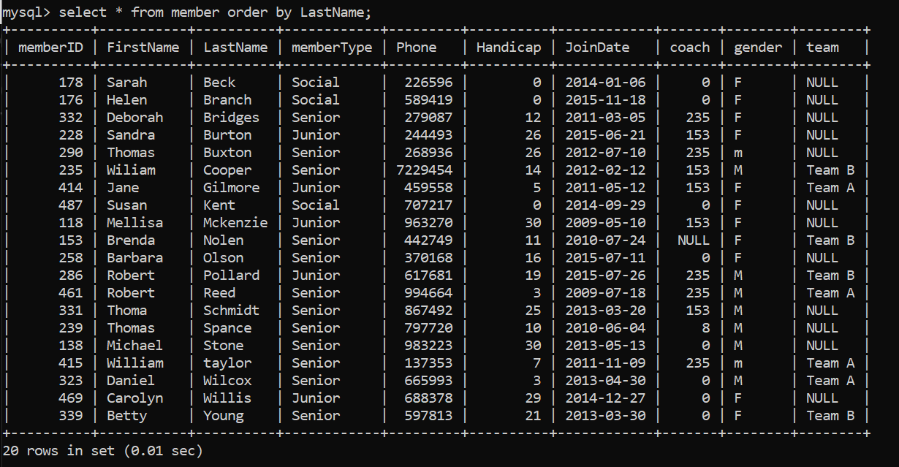

g) Retrieve the number of records in Member table.
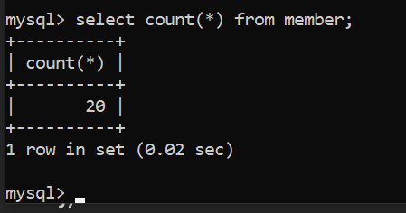

h) Provide the first name and last name of the two coaches.
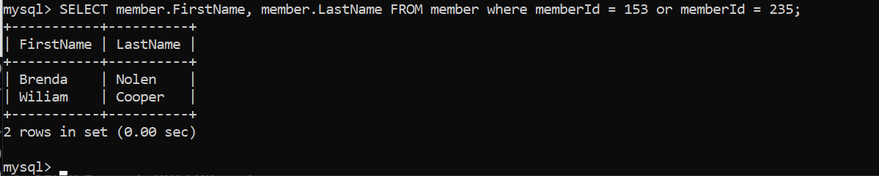

i) Find the amount of fee provided by each member by mentioning member first name, last name, and fee. (Hint: use the member and type tables.)
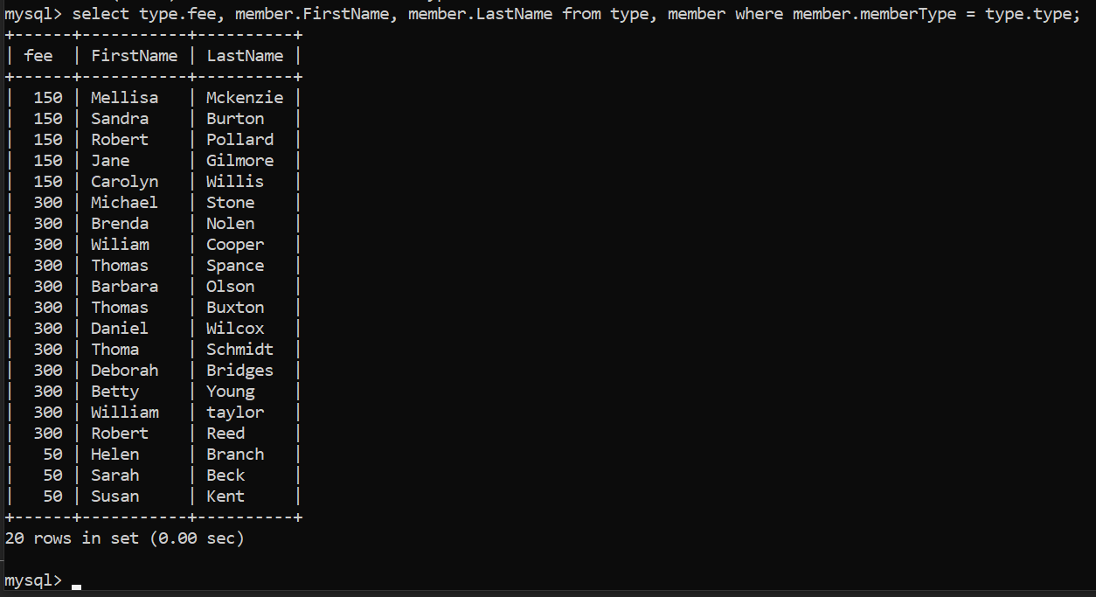

j) Delete the record from Entry table where Member=415 and TourID=40.

k) Update the Fee of Associate in Type table from 60 to 80.
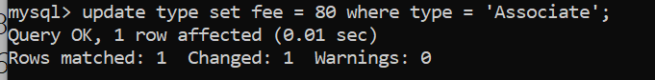

Task 4.8:

Numeric Functions:
CEIL (Ceiling): This function gives the smallest integer greater than or equal to a given numeric expression.
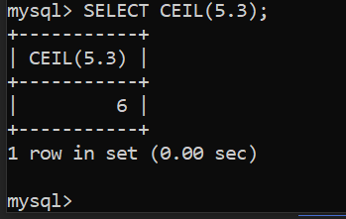
COS (Cosine): Returns the cosine of an angle (in radians).
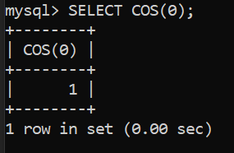
DEGREES: Converts radians to degrees.
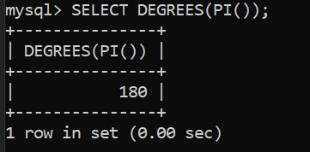
LOG10: Returns the base-10 logarithm of the argument.
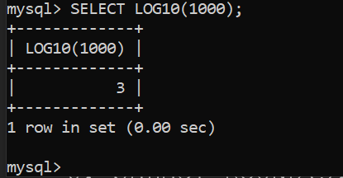
MOD: Returns the remainder after dividing the first argument by the second argument.
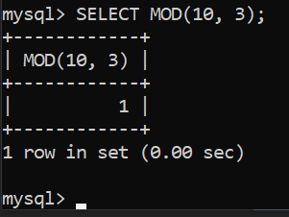
RADIANS: Converts degrees to radians.
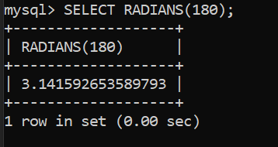

ROUND: Rounds a number to the nearest integer.
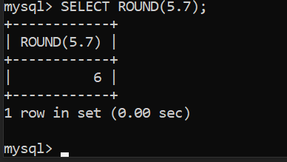
SQRT (Square Root): Returns the square root of the argument.
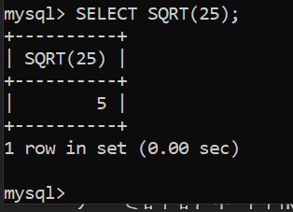
TRUNCATE: Truncates a number to a specified number of decimal places.
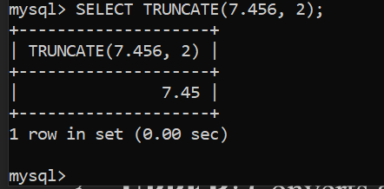

String Functions:
CONCAT: Concatenates two or more strings.
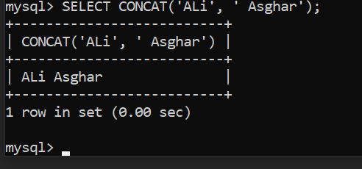
UPPER: Converts a string to uppercase.
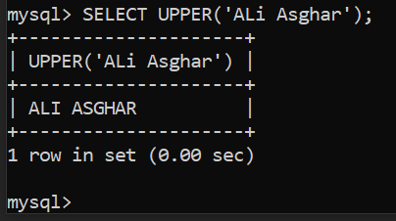
LOWER: Converts a string to lowercase.
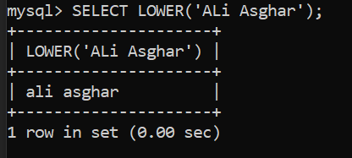
REPEAT: Repeats a string a specified number of times.
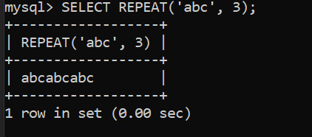
REVERSE: Reverses the characters in a string.
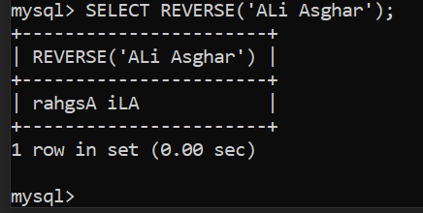
REGEXP: Checks if a string matches a regular expression.
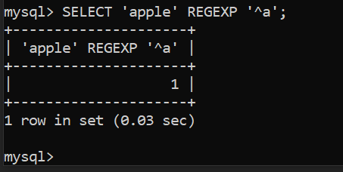
REPLACE: Replaces occurrences of a specified string.
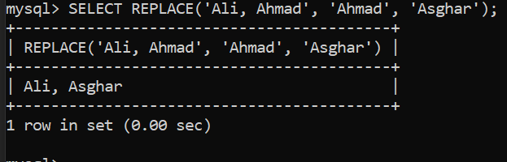
LENGTH: Returns the length of a string in bytes.
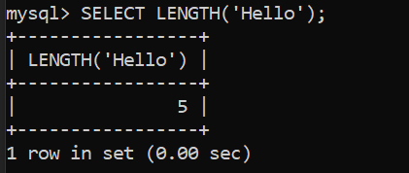
LTRIM (Left Trim): Removes leading spaces from a string.
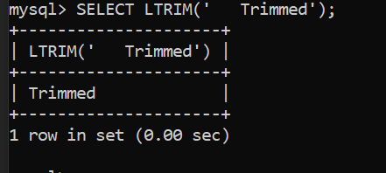
RTRIM (Right Trim): Removes trailing spaces from a string.
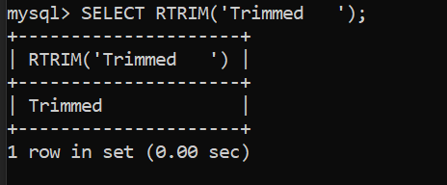

Date & Time Functions:
CURDATE: Returns the current date.
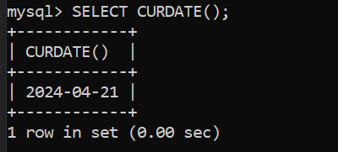
WEEK: Returns the week number for a date.
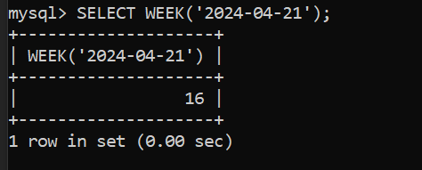
DATE_FORMAT: Formats a date as specified.
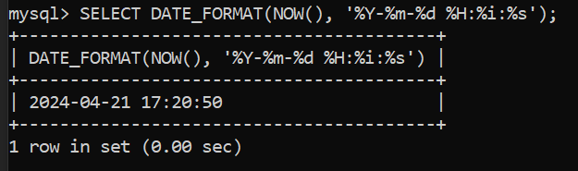
QUARTER: Returns the quarter from a date.
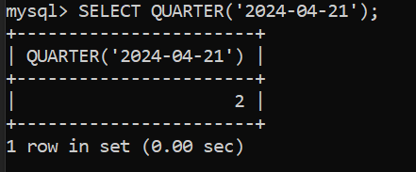
NOW: Returns the current date and time.
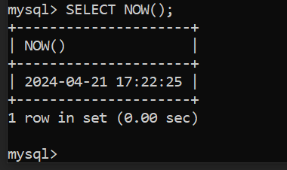
SYSDATE: Returns the time at which the function executes.
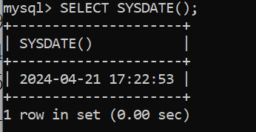

Task 4.9:
Comparison:
!=
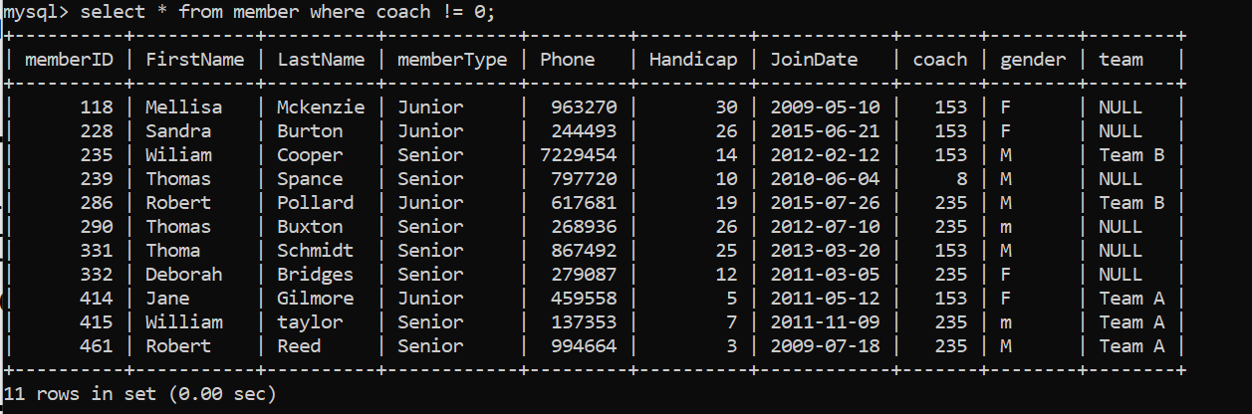

>
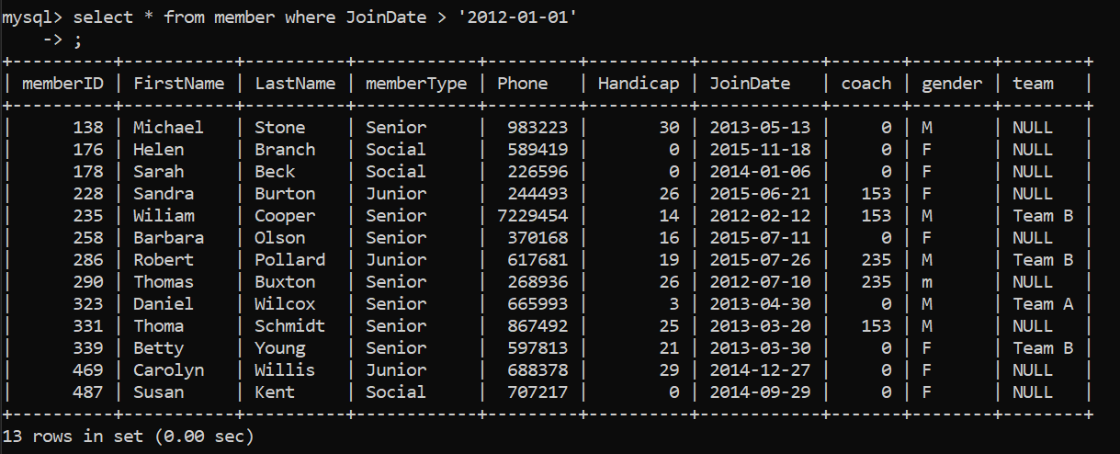

Boolean:
AND
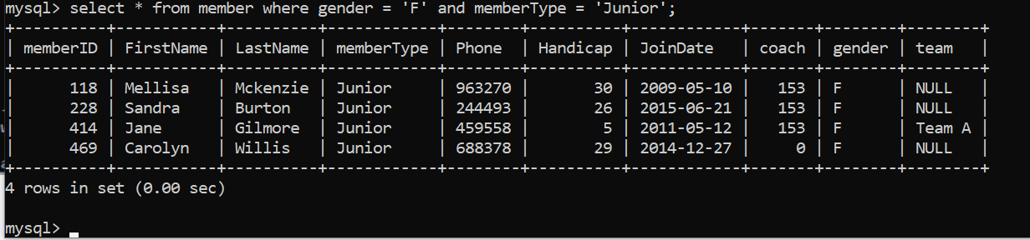

OR
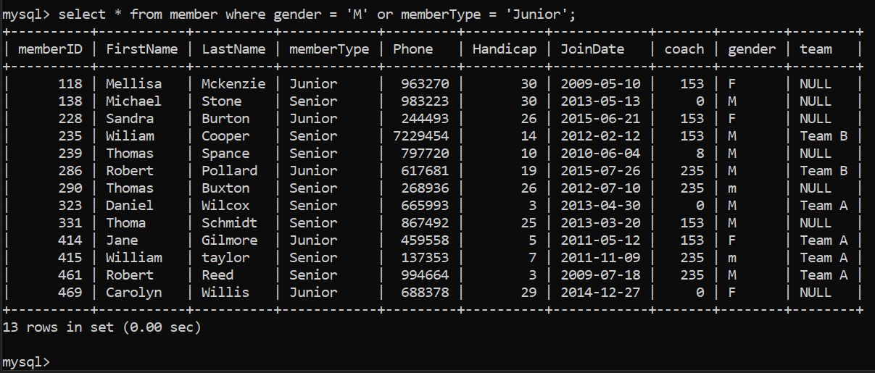

Special Operators:
distinct:
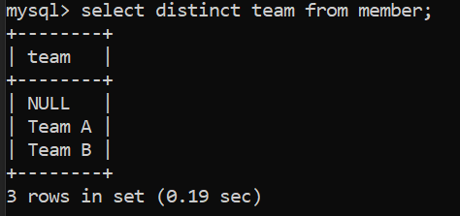

between:
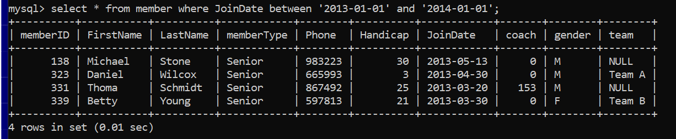

Task 4.10:
a) Add new column DOB to store member date of birth. Its type is date and can be null.
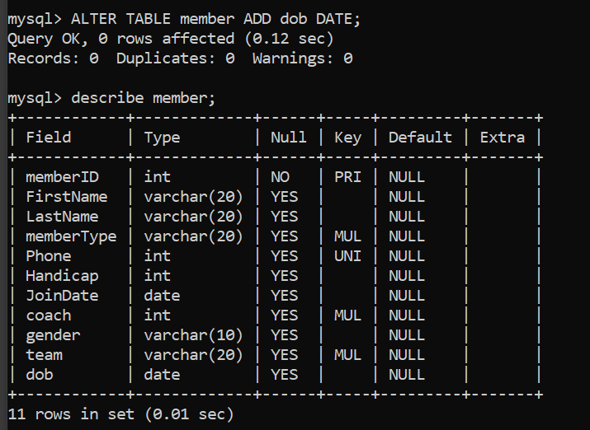

b) Now change the name of newly added column from DOB to M_DOB with date as data type and not null.
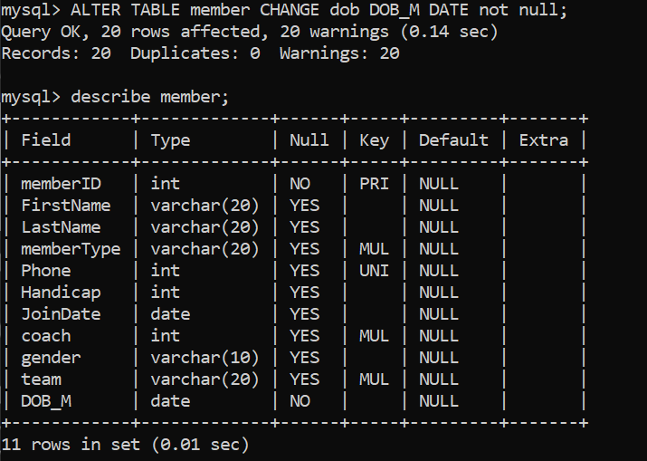

c) Now drop the M_DOB column from member table.
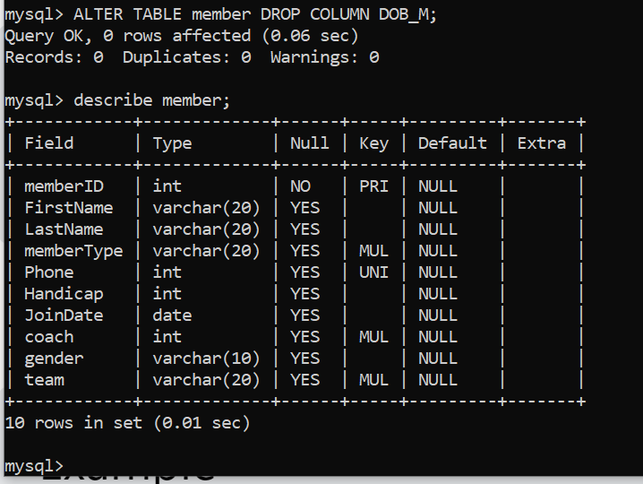

d) Next drop the primary key TourID from tournament table.
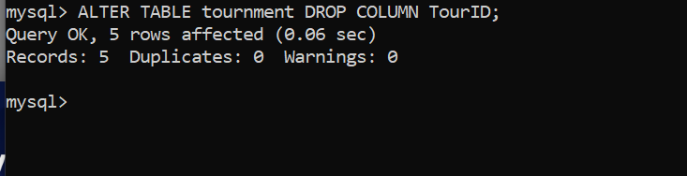

e) Now add new primary key TourID into tournament table.
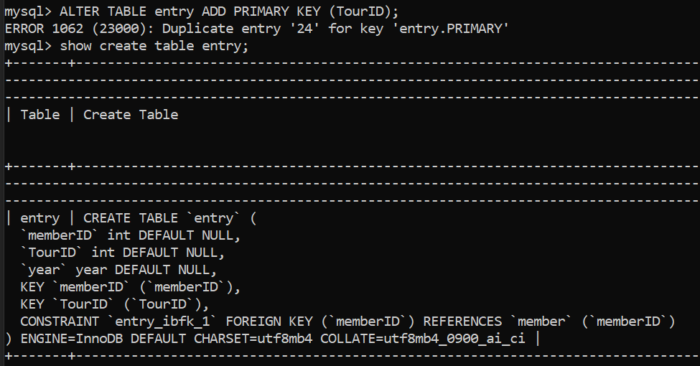
f) Next drop the foreign key Coach from member table.
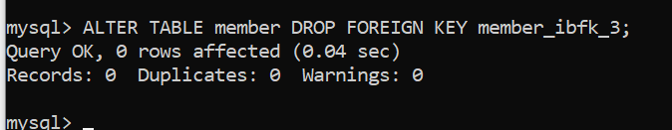

g) Now add the new foreign key Coach from member table.
